
Rowsley C of E Primary School Pupil premium strategy statement 2023/26
- Written June 23

This statement details our school’s use of pupil premium (and recovery premium for the 2023 to 2024 academic year) funding to help improve the attainment of our disadvantaged pupils.

It outlines our pupil premium strategy, how we intend to spend the funding in this academic year and the effect that last year’s spending of pupil premium had within our school.

School overview
Detail | Data
School name | Rowsley C of E Primary School
Number of pupils in school | 61
Proportion (%) of pupil premium eligible pupils | 47%
Academic year/years that our current pupil premium strategy plan covers (3 year plans are recommended) | £33.545
Date this statement was published | 23.06.23
Date on which it will be reviewed | 23.06.24
Statement authorised by | Alexia Wyer
Pupil premium lead | Alexia Wyer
Governor / Trustee lead | Claire Hewitt
Funding overview
Detail | Amount
Pupil premium funding allocation this academic year | £33.545
Recovery premium funding allocation this academic year | £3190
Pupil premium funding carried forward from previous years (enter £0 if not applicable) | £0
Total budget for this academic year | £36, 545

Part A: Pupil premium strategy plan

Statement of intent
At Rowsley Primary School we ensure that all of our pupils can thrive and ‘Live life in all its fullness’ (John 10:10) and recognise that in order to achieve this some pupils will need extra support and guidance.
Principles:
- We ensure pupils leave us at the end of KS2 with the attitudes, knowledge, skills and confidence to succeed.

- We inspire and enable our school community to be great learners and great people.
• We would like to bridge the gap in accelerating academic results in Literacy and Numeracy, allowing more individual tailoring of resources to suit their academic needs.
• We would also like to give them opportunities to explore their creativity and interests within our nurturing school ethos and extra opportunities. We notice and celebrate uniqueness and individuality.
• We want to provide the ability to become more independent and improve their social skills.
• We aim to increase their employability skills within a careers program. We equip pupils and families with the knowledge, skills, independence and resilience to face future challenges.
• We create nurturing, challenging and empowering learning opportunities for all pupils.
• We foster positive working relationships with parents and pupils.

Challenges

This details the key challenges to achievement that we have identified among our disadvantaged pupils.
Challenge number | Detail of challenge
1 | Underdeveloped communication skills, including oral language and vocabulary gaps. This is evident from Reception through to Key Stage 2 and in general, is more prevalent among our disadvantaged pupils than their peers.
2 | Disadvantaged pupils generally have greater difficulties with phonics, which negatively impacts their development as readers.
3 | Increased social and emotional needs of pupils, including more frequent behaviour issues in school. The education and wellbeing of many of our disadvantaged pupils (and their families) continue to be affected by the impact of the pandemic (as per the findings of national studies). Teacher referrals for support remain relatively high and there is an increase in the number of disadvantaged pupils with multiple needs i.e. PP pupils with SEND.
4 | Attainment among disadvantaged pupils in reading, writing and maths (including the multiplication tables check) is below that of non-disadvantaged pupils. When many of our disadvantaged pupils join the school they are below age-related expectations compared to their peers.
5 | Supporting parent with issues at home such as financial issues and parent mental health.

Intended outcomes
This explains the outcomes we are aiming for by the end of our current strategy plan, and how we will measure whether they have been achieved.
Intended outcome | Success criteria
Children in receipt of the Early Years PPG will make good or better progress in Communication and Language | Increase in verbal comprehension.  Increased vocabulary used  Increased use of verbal description. Increased understanding of simple tasks set.  Use of appropriate vocabulary for self-help requests.
Improved outcomes in Reading for PP Pupils | Children in receipt of the PPG will do as well (or better) than non-disadvantaged children and will reach at least the expected level in Reading in KS1 and KS2
Improved outcomes in Writing for PP Pupils | Children in receipt of the PPG will do as well (or better) than non-disadvantaged children and will reach at least the expected level in writing in KS1 and KS2
Improved outcomes in Maths for PP Pupils | Children in receipt of the PPG will do as well (or better) than non-disadvantaged children and will reach at least the expected level in maths in KS1 and KS2
Ensure no child is disadvantaged due to financial difficulties at home | Children will access all clubs, trips and have access to resources free or at a heavily discounted rate.
The families of disadvantaged children will be well supported with targeted assistance as required. | Parents will be supported by the Wellbeing and Behaviour Support Lead and the Family Support Worker to access opportunities that will improve outcomes for their families
Opportunities to increase exposure to Cultural Capital will be created and disadvantaged children will be proactively selected to engage with these. | Careful consideration will have provided many and varied opportunities for children, this will include financial support to ensure that they are able to actively participate

Activity in this academic year
This details how we intend to spend our pupil premium (and recovery premium funding) this academic year to address the challenges listed above.

Tier 1: Teaching (for example, CPD, recruitment and retention)
Budgeted cost: £6, 632.26
Activity | Evidence that supports this approach | Challenge number(s) addressed
Professional development on evidence based approaches for developing metacognition in pupils  £500 | EEF highly recommends developing metacognition in pupils to help with not only attainment but with the mental health and resilience of pupils. | 2, 4
To ensure EYFS children are supported effectively to develop speech and language skills.  Hire and train an additional member of staff to coordinate the NELI approach and other SP&lan interventions.  To ensure Oracy and vocabulary is promoted across the school to develop children’s language skills this  £3,000- cost for TA intervention x 3 per week for approx. 6 pupils. | Engagement in the Nuffield Early Language Intervention (NELI) Programme for highlighted pupils.  The EEF advocate the use of the NELI programme. It has been robustly evaluated through a randomised control trial between June 2018 and November 2019. The results provide strong evidence for the effectiveness of the NELI programme. NELI children made an average of 3 ADDITIONAL months’ progress in language. This result has a very high security rating: 5 out of 5 on the EEF padlock scale. The cost of NELI is £58 per child (where the programme is used over 3 years with 5 children per year).  A language rich environment is provided; all staff are trained to support acquisition of key skills.  High quality texts will be used where appropriate to allow children to access a rich range of vocabulary and this will be highlighted within lessons and provided on display for children to access when writing independently. PP pupils to have their own copy of class texts to keep.  High quality texts also available for access through reading schemes and school library.  Learning walks allow specific observation for the teaching of vocabulary and specific resources developed to help this Library and reading scheme constantly updated to develop a love for reading to allow greater access to a rich range of vocabulary.  Reading challenge introduced the help develop the range of texts read and further develop the love for reading of the children | 1
Extra classroom support for English and Maths sessions to help support the lowest 20%+ pupils.  £2, 000 | Individualised instruction +4 Months  https://educationendowmentfoundation.org.uk/educationevidence/teaching-learning-toolkit/individualisedinstruction  Small group tuition +4 months  https://educationendowmentfoundation.org.uk/educationevidence/teaching-learning-toolkit/small-group-tuition | 1, 2, 4
Whole class music lessons for the whole of KS2 for 14 weeks.  £747.26 – I haven’t had a final cost for this yet, but would estimate it to be around the same as this year’s | Learning something new as a whole group, being part of something collaborative. Awe and wonder for something they may not have had an opportunity to access before.  EEF State: Overall, the average impact of arts participation on other areas of academic learning appears to be positive but moderate, about an additional three months progress. Some arts activities have been linked with improvements in specific outcomes. For example, there is some evidence of the impact of drama on writing and potential link between music and spatial awareness. Wider benefits such as more positive attitudes to learning and increased wellbeing have also consistently been reported. | 3
Individual music lessons  £385  X 3 pupils | 1:1 music lessons in guitars, keyboards and drums. PP pupils signed up for individual or group music lessons. Their enthusiasm for lessons and dedication to learning has been noticeable.  EEF State: Overall, the average impact of arts participation on other areas of academic learning appears to be positive but moderate, about an additional three months progress. Some arts activities have been linked with improvements in specific outcomes. For example, there is some evidence of the impact of drama on writing and potential link between music and spatial awareness. Wider benefits such as more positive attitudes to learning and increased wellbeing have also consistently been reported. | 3

Tier 2: Targeted academic support (for example, tutoring, one-to-one support structured interventions)
Budgeted cost: £13, 288.80
Activity | Evidence that supports this approach | Challenge number(s) addressed
Tutor hired though the School Led Tutoring Grant and NTP programmes.  £3, 190 | Small groups allow for targeted teaching to address gaps in learning, misconceptions and to boost confidence  EEF State: Small group tuition has an average impact of four months’ additional progress over the course of a year. Small group tuition is most likely to be effective if it is targeted at pupils’ specific needs. Diagnostic assessment can be used to assess the best way to target support. One to one tuition and small group tuition are both effective interventions. However, the cost effectiveness of teaching in small groups indicates that greater use of this approach may be worthwhile. Additional small group support can be effectively targeted at pupils from disadvantaged backgrounds, and should be considered as part of a school’s pupil premium strategy.  Small group tuition | EEF (educationendowmentfoundation.org.uk) | 2, 4
ELSA training  £575 | ELSAs are emotional literacy support assistants. They are teaching assistants who have had special training from educational psychologists to support the emotional development of children and young people in school. | 3
Social, Emotional, Mental, Health (SEMH) interventions  £5, 428.80- cost for SEMH intervention x 3 afternoons per week. | School is able to provide support to children with SEMH needs and liaise with outside professionals and parents to ensure that children are correctly signposted to the correct professionals needed to support them.  School will provide lego therapy and nurture by a trained professional.  Evidence from the EEF states:  The average impact of behaviour interventions is four additional months’ progress over the course of a year. Evidence suggests that, on average, behaviour interventions can produce moderate improvements in academic performance along with a decrease in problematic behaviours. However, estimated benefits vary widely across programmes. | 3
Delivery of Little Wandle KS2 Rapid Recovery Programme for pupils who have been assessed (LW assessment and Collins Fluency Assessment) as still needing phonics.  TA to deliver additional phonics to ‘catch-up’ groups to all KS1 pupils identified as needing catch up.  £1638  TA at 3.25 hours a week (Grade 7, point 11 as most of our TAs are top of grade, 3.25 hours x 39 weeks) | Little Wandle has been validated by the DfE as a complete Systematic Synthetic Phonics programme.  Research conducted by the EEF has found that:  Synthetic phonics approaches have higher impacts, on average, than analytic phonics approaches.  Studies have shown that a full commitment to catch up and KS2 programmes are needed to be fully affected. | 2
Reading intervention and focussed SPAG intervention groups with TA, to ensure that pupils in need can be targeted.  £1638  TA at 3.25 hours x 39 weeks) | The EEF reports that:  Scientific research has consistently recognized the critical nature of fluency as a bridge between effortful decoding and comprehension. Another component of fluency that links word recognition to comprehension is prosody (or expressive oral – and silent – reading). Think of anyone you would consider a fluent reader: not only do they decode words automatically, but they also read the words in texts with expression and phrasing that reflects and amplifies the meaning of the text. To read with appropriate expression and phrasing requires the reader to access the meaning of the text. Readers who read with high levels of word recognition automaticity and with good prosody tend to be the most proficient readers. Lower levels of automaticity and prosody are associated with lower levels of comprehension and overall proficiency.  Moreover, research has also demonstrated that a significant number of pupils in secondary school who struggle to become proficient readers also exhibit difficulties in reading fluency.  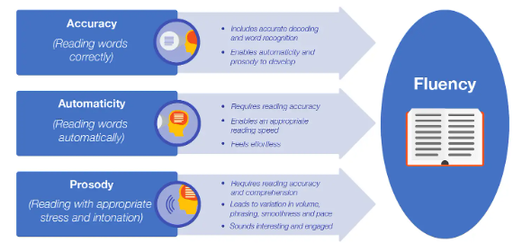 | 4
Action words intervention groups with TA, to ensure that ALL pupils can read high frequency words.

£819
TA at 1.8 hours x 39 weeks)

Tier 3: Wider strategies (for example, related to attendance, behaviour, wellbeing)
Budgeted cost: £17, 092
Activity | Evidence that supports this approach | Challenge number(s) addressed
Breakfast and After School Club  £2392 morning club  School’s finance would need to provide figures for ASC, as this is centrally-run payroll to the Extended Services code  Plus £700 for food parcels  Funded ASC places £2000 | EEF State: My message to schools is this. The model of pre-school breakfast clubs the EEF trialled – free and universal – appears to have clear benefits to pupils. In addition to the positive attainment impact found for pupils in Year 2, the independent evaluation also found both improved attendance and behaviour in schools. Most importantly, breakfast clubs help ensure that no child has to learn when they’re hungry. | 2, 5
Targeted support for parents that signposts relevant and helpful professionals and organisations | Parent voice tells us that they often do not know where to turn to find advice and support. Offering suggestions via school can be supportive and also ensures that recommendations are up-to-date and offer quality services to the local community 5 | 3, 5
Children will engage in varied opportunities that promote cultural capital  £500 – Inviting a guest speaker/skilled personal i.e. art day. | We know that our disadvantaged children often miss out on extracurricular opportunities that add breadth to their life experience. By providing these through school and subsidising them financially for our PPG pupils we can ensure that all children are offered the same rich provision | 3, 5
Ensuring our disadvantaged pupils can access all our extracurricular activities including residentia  £2000 |  | 3, 5
Purchase class text for pupil premium pupils so they can read along with the class teacher and take the book home to engage with text at home.  £1500 |  | 2, 4
Early Help Practitioner  2x days per week  £8, 000 |  | 3, 5
Total budgeted cost: £37, 013.06

Part B:

Review of outcomes in the previous academic year

Pupil premium strategy outcome
This details the impact that our pupil premium activity had on pupils in the 2022/23 academic year.
Outcomes for the academic year: 2022- 2023
Phonics: All teachers continued to receive access to the Little Wandle phonics training videos and 1 £9,000 grant to update our reading books and resources. The school achieved a pass rate of 70% in theY1 Phonics Screening Check. PP % will not be published as it was a small cohort.
Reading: Reading continues to be promoted throughout the school by the reading lead. Several love of reading events were carried out across the year – including World Book day and our annual Christmas Book Day as well as taking part in holiday reading challenges, both in house and national. Due to low pupil premium numbers in some years we have not published the data as pupils may be identified. However across school:
The progress of pupil last year shows that our pupil premium pupils make just as good, if not better progress than non PP pupils. Please not th grey area are new pupils without prior data.
Pupil Premium progress at the end of 22/23 academic year:
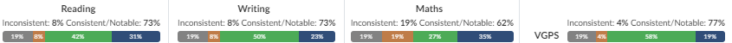

Whole School progress (PP and non PP):
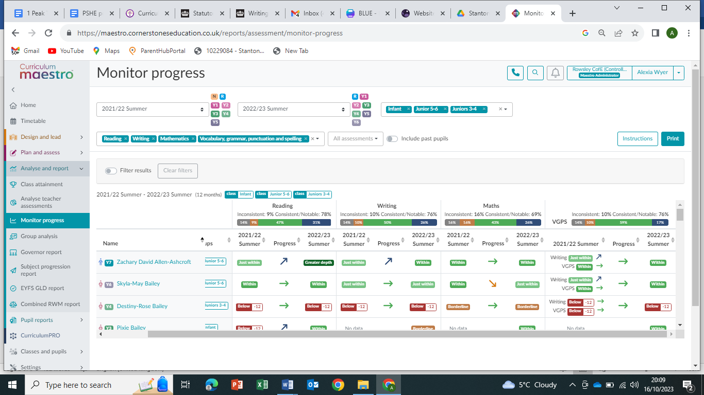
Attendance: 22/23
Non Disadvantaged- 95.0%
Disadvantaged - 94%
Disadvantaged attendance still remains slightly lower than non- disadvantaged. We continue to work with the families of the children. We have hired a Family Support Worker for two days a week to help support our families and improve attendance.
The school subsidises all trips and residentials for PP pupils: A whole school trip to the theatre (EYFS/KS1), a whole school trip to the zoo, residentials: yr 5/6 Mount Cook and yrs 3/4/5&6 Edale. Plus a trip for ½ to see a castle and a trip to the Stone Age Centre (yr ¾).

Externally provided programmes
Please include the names of any non-DfE programmes that you purchased in the previous academic year. This will help the Department for Education identify which ones are popular in England
Programme | Provider
TT Rockstars | TT Rockstars
Spelling Shed | Ed Shed
Residential for years 5/6 | Edale and residential trip to Manchester

Service pupil premium funding (optional)
For schools that receive this funding, you may wish to provide the following information:
Measure | Details
How did you spend your service pupil premium allocation last academic year? | n/a
What was the impact of that spending on service pupil premium eligible pupils? | n/a

