20th February 2025
Dear Parents and Carers,

This year World Book Day will take place on Thursday, 6th March.

This year’s World Book Day invites everyone to ‘Read Your Way’. Research shows that children feel reading is something they have to do, rather than something they choose to do. ‘Read Your Way’ encourages everyone to let go of reading pressures and expectations and empowers children and young people to have fun discovering reading on their own terms.

Levels of reading enjoyment are currently at an all-time low, so it is now more important than ever to get our children excited about reading for fun, unlocking the proven benefits it brings, including better wellbeing and improved learning across the school curriculum.

World Book Day is just one day where we can celebrate the joy and value of books and aims to change lives through a love of books and shared reading. We want to encourage all children to love reading, because it’s one of the most important ways to improve their life chances. At Rowsley C of E Primary we want all children to understand the important message of ‘you are a reader.’

To help get children along their reading journey, every child will receive a World Book Day Book token which can be used locally at Scarthin Books, Cromford; Sainsbury’s, Matlock; Waterstones, Chesterfield; and The Works in Peak Village.

This year, for World Book Day, there a range of things the children can do. You only need to choose one!

- Dress up as your favourite book character
This has always been well received, and we always do a parade so that we can see all the amazing costumes.
Please do not go to any great expense though. Costume ideas can be found easily with a Google search. If you are struggling for ideas, please see one of the members of staff at school. This is just for fun and we will not be asking for donations to come in costume on this day. Coming as a muggle is always a good option!

- Wear a Hat
Decorate and wear a hat with a book theme.
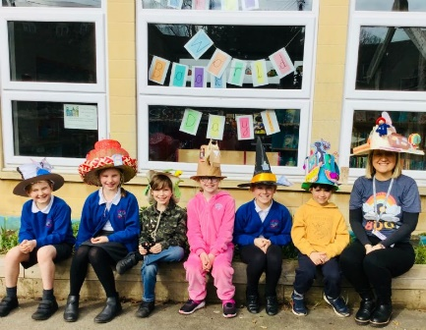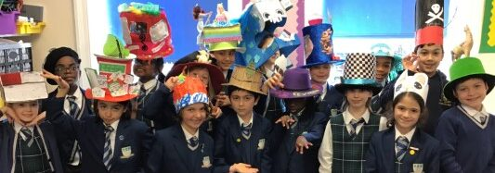

- Dress a Potato Book Character
Turn an ordinary potato into a book character of your choice! You can use pens, paint, fabric, paper, card, recycled items or any craft materials you may have at home to add features and costumes to your potato. A simple tip to help your potato stand up is to cut a section from a cardboard toilet roll. It should sit in it comfortably – unless you have a strange-shaped potato!
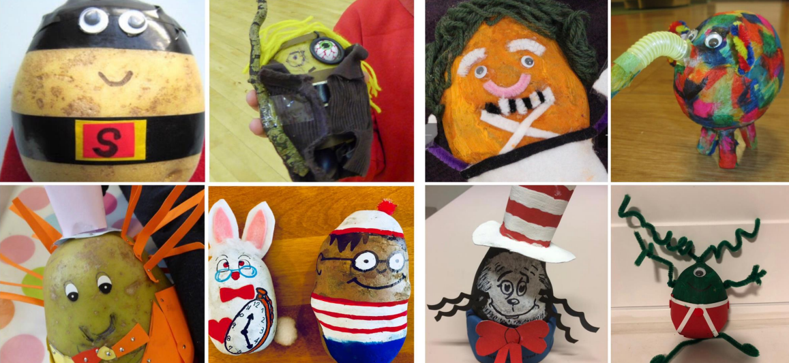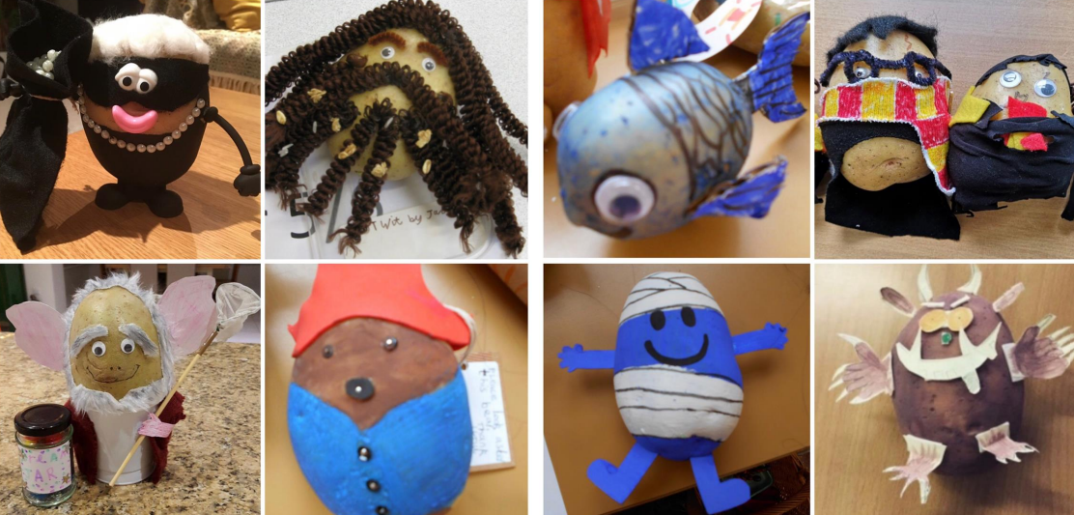

Year 5/6 Only
Year 5/6 will be taking part in The Great Big Footy and Booky Quiz. This is a live online event. The 45-minute quiz will feature two rounds of questions (one football-themed, one reading-themed) pitched by some footballing heroes and authors. Due to this, the Year 5/6s can come in football kits, if they wish.

If you have any questions or queries about this day, please contact me at c.hewitt@peaktorfedertaion.co.uk

Yours sincerely,

Claire Hewitt
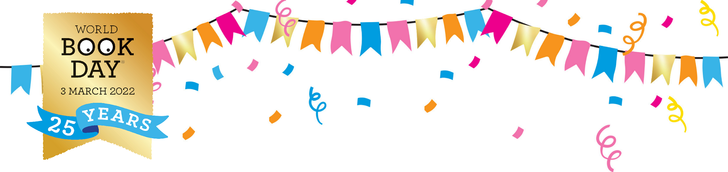
(English Co-ordinator)

