World book day costume ideas (everyday wear)
EYFS & KS1
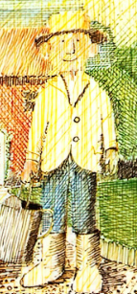
Mr Gumpy – from Mr Gumpy’s Outing
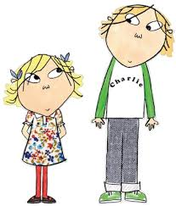
Charlie & Lola
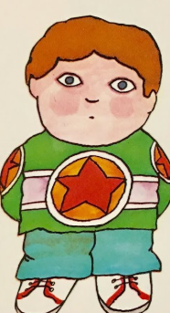
The boy from Not Now, Bernard
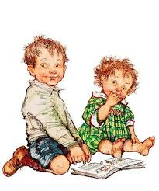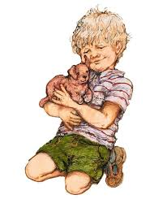
Any of the children from Shirley Hughes Books

Y3/4
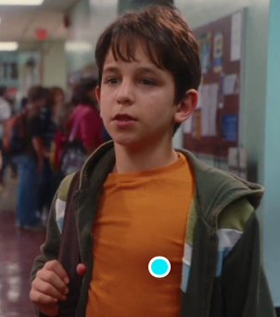
Greg Heffley, Diary of a Whimpy Kid
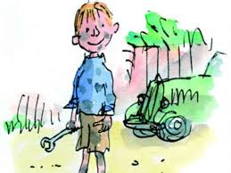
Danny from Danny the Champion of the Wolrd
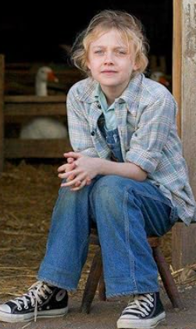
Fern from Charlotte’s Web
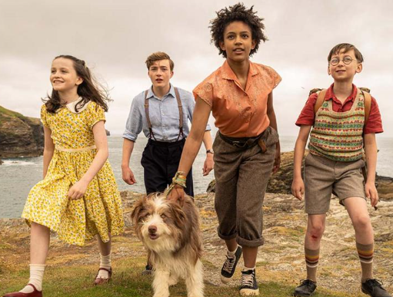
Any of the children from the Famous Five books

Y5/6

Lyra or Will from His dark Materials
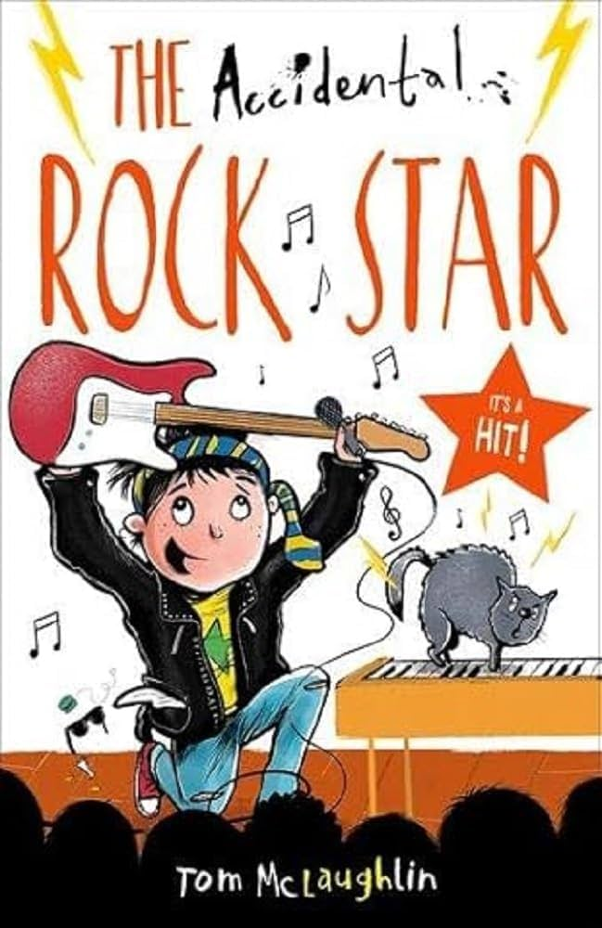

Alex Ryder by Anthony Horrowitz
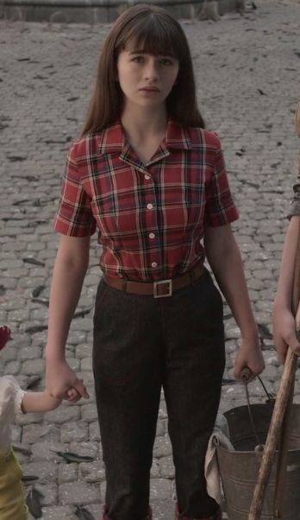
Violet from a Series of Unfortunate Events

