.
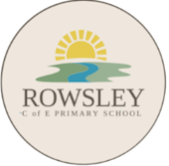
Rowsley Church of England Primary School
Music Progression and Long Term Plan (updated February 2026)
“Praise him with the sound of the trumpet: praise him with the psaltery and harp. Praise him with the timbrel and dance: praise him with stringed instruments and organs. Praise him upon the loud cymbals” Psalm 150

“Life in all its fullness.” John 10:10

Intent
At Rowsley C of E Primary, we hope to nurture and grow the inherent interest in and love for music that can be observed in all young children. We aim to inspire children to be creative composers, appreciative listeners and confident performers of a wide range of musical styles and genres. We believe that music is a wonderful means of bringing people together and as such we strive to provide children with musical experiences which bring children together within their classes, the whole school and even our local community, including through performances, assemblies and church services. Additionally, we aim to provide high-quality lessons within each of our classes which progressively build children’s tacit, procedural and declarative knowledge as they move through school.
Implementation
The teaching of music at Rowsley is multi-faceted, ensuring children are given ample opportunity to sing, listen, play, perform and evaluate, and that the skills and knowledge they develop in each of these areas is built on every year. We understand the importance of practice within the discipline of music, and as such focus on deepening children’s skills in focused areas.
The ways in which we teach music are as follows:
- Whole class instrumental lessons – For three half terms in both Y3 and Y4, children receive instruction from a specialist music teacher in playing an instrument and reading musical notation, culminating in a performance to parents. As part of these lessons, children also explore improvisation and composition on the instrument they are learning.
- Class lessons – Children participate in discrete music lessons based on National Curriculum objectives. We use the Get Set 4 Music scheme of work in Reception, KS1 and UKS2. Children in KS1 focus on exploring music through singing and playing untuned instruments and the glockenspiel. Children in UKS2 use their voices and also play glockenspiels. Lessons also involve listening and evaluating.
- Musician/Composer of the Term – Every term, each class focuses on a different musician or composer. These have been chosen to cover a range of time periods and musical genres. Children focus on
- Performances – EYFS and KS1 children deliver a Christmas performance annually based around singing ; KS2 children put on a performance every summer term. Within these, all children sing and some children perform on tuned and untuned instruments. At the end of the block of whole class instrumental lessons, children in Y3/4 perform to parents.
- Assemblies – Every Monday, children practise singing together during our singing assembly. They also often listen to music from different genres.
- Individual instrument lessons - We invite peripatetic teachers into school to teach individual lessons for children who want to learn an instrument. Children learning instruments have the opportunity to perform in church services and assemblies.
- Choir - All children from Y2 upwards are invited to join our choir, which usually runs in the autumn term.
- Continuous provision – Children in Reception have access to musical instruments as part of their continuous provision and are encouraged to explore these. Children in this year group also sing together frequently, learning a range of songs including nursery rhymes. This is in addition to a weekly Get Set 4 Music lesson.
Impact
Our children enjoy music in different ways – they are confident performers, they can discuss how listening to music makes them feel and they can use their knowledge and skills to develop new music using their voice and/or instruments. Children develop their musical vocabulary every year and by Year 6 are familiar with a wide range of performers and composers from different time periods and genres. They understand that music has cultural and historical significance when learning about different people, places and time periods.

Statutory Requirements: EYFS and National Curriculum
EYFS | KS1 | KS2
Children at the expected level of development will:  Sing a range of well-known nursery rhymes and songs  Perform songs, rhymes, poems and stories with others, and – when appropriate – try to move in time with music | Pupils should be taught to:  Mu1/1.1 use their voices expressively and creatively by singing songs and speaking chants and rhymes  Mu1/1.2 play tuned and untuned instruments musically  Mu1/1.3 listen with concentration and understanding to a range of high-quality live and recorded music  Mu1/1.4 experiment with, create, select and combine sounds using the interrelated dimensions of music | Pupils should be taught to:  Mu2/1.1 play and perform in solo and ensemble contexts, using their voices and playing musical instruments with increasing accuracy, fluency, control and expression  Mu2/1.2 improvise and compose music for a range of purposes using the interrelated dimensions of music  Mu2/1.3 listen with attention to detail and recall sounds with increasing aural memory  Mu2/1.4 use and understand staff and other musical notations  Mu2/1.5 appreciate and understand a wide range of high-quality live and recorded music drawn from different traditions and from great composers and musicians  Mu2/1.6 develop an understanding of the history of music.

Termly Overview of Music Teaching and Experiences
Writing in italics refers to Get Set 4 Music unit of work. The information in brackets denotes the curriculum cycle.
 | Autumn 1 | Autumn 2 | Spring 1 | Spring 2 | Summer 1 | Summer 2
EYFS | All About Me  Harvest service | Singing lessons  Nativity performance  Christmas Service | Around the World | Journeys  Easter Service | Traditional Tales | Circus  Leavers’ service
KS1  . | Seasons (C1)  Folk Songs (C2)  Harvest service | Singing lessons  Nativity performance  Christmas Service  Christmas Choir (extra-curricular) | Senses (C1)  Toys (C2) | Superheroes (C1)  Oceans (C2)  Easter Service | Fantasy and Adventure (C1)  Great Fire of London (C2) | Dinosaurs (C1)  Carnival of the Animals (C2)  Leavers’ service
Y3/4 | Whole Class Instrumental lessons  Harvest service | Whole Class Instrumental lessons  Christmas Service  Christmas Choir (extra-curricular) | Whole Class Instrumental lessons | History of Music lessons (C2)  Easter Service | Singing lessons | Singing lessons  KS2 performance  Leavers’ service
Y5/6 | Reggae (C1)  World War II (C2)  Harvest service | Melodies of Divinity (C1)  Arctic (C2)  Christmas Service  Christmas Choir (extra-curricular) | Bandlab (C1)  Animal Kingdom (C2) | Rock and Roll (C1)  Planets (C2)  Easter Service | Singing lessons | Singing lessons  KS2 performance  Leavers’ service

Additionally, in the autumn, spring and summer terms each class focuses on one Musician of the Term, learning about musicians and composers from across different time periods and genres (see next page).

Musician of the Term

Y1/2 | Cycle 1 | Beethoven  Classical composer | Kishori Amonkar  Musical traditions – India, classical | Abba  Pop/Disco
Y1/2 | Cycle 2 | Hans Zimmer  Twenty-first century composer | Babatunde Olatunji  Musical traditions – Nigeria, drumming | Freddie Mercury  Rock
Y3/4 | Cycle 1 | Gustav Holst  Twentieth century composer | Alan Dawa Dolma  Musical traditions – Tibet, folk | Bellowhead  Contemporary folk
Y3/4 | Cycle 2 | Tchaikovsky  Romantic composer | Billy Strings  Musical traditions – USA, bluegrass | The Beatles  Pop
Y5/6 | Cycle 1 | Anna Meredith  Twenty-first century composer | Buena Vista Social Club  Musical traditions – Cuba, son cubano | Bjork  Alternative
Y5/6 | Cycle 2 | Vivaldi  Baroque composer | Te Waka Huia  Musical traditions – New Zealand, haka | Bob Marley  Reggae

Skills and Knowledge Progression
 | EYFS | Y1 | Y2 | Y3 | Y4 | Y5 | Y6
Performing | Use my voice to speak and sing and know that they are different.  Copy simple rhythms on an untuned  instrument.  Explore how to make sounds on different untuned instruments.  Add sound effects to enhance a song.  Add actions to song. | Accompany singing with actions and body sounds, playing to a steady pulse.  Sing simple songs in different styles with awareness of pitch and clarity in diction.  Begin to control sounds – gradually louder/quieter/  faster/slower.  Follow simple performance indicators (start, stop, change dynamics).  Follow simple dot notation. | Sing with developing control of pitch and diction.  Begin to control breathing when singing with an awareness of phrasing.  Follow pitch direction given by gesture.  Follow a conductor with increasing accuracy.  Find and perform the pulse with increasing success.  Begin to control sounds with intention.  Control my voice or instrument when performing a piece with contrasting dynamics.  Relate simple dot notation to changes in sound.  Explore, use and recognise changes in timbre, pitch, dynamics and tempo.  Demonstrate increased confidence following musical directions given aurally and physically.  Use percussion instruments and body percussion to repeat simple rhythms. | Hold my tuned instrument correctly with the right posture.  Recognise hand signals for do-so pitch.  Develop the voice for singing in a group, including vocal care awareness.  Perform on a tuned instrument as part of an ensemble.  Understand performance etiquette when playing for an audience.  Follow a conductor when playing as part of an ensemble. | Maintain an ostinato within a two- or three-part piece on a tuned instrument.  Accurately perform a tuned instrument as part of an ensemble.  Demonstrate  performance etiquette when playing for an audience.  Hold a singing part in a small group as part of a canon.  Sing with accurate pitch in unison with others. | Sing and play to convey mood and emotion.  Sing confidently, matching pitch across a range of notes, leaps, lengths and rhythmic complexity.  Confidently demonstrate a secure sense of pulse when singing and playing in different time signatures. | Sing confidently with control and expression, accurately matching pitch across a range of notes both singing in unison or in parts.  Demonstrate a secure sense of pulse when singing and playing in different time signatures both in unison and within an ensemble.  Perform with an awareness of the audience and the message the music is trying to convey.  Demonstrate musicality in the control and production of sound using expression.  Self-correct if part of a performance goes wrong.
Creating (including musical notation) | Create my own music and say what I think about it.  Play an untuned instrument as part of a group.  Understand that written symbols or pictures can relate to the music being played. | Begin to improvise simple rhythms.  Explore written symbols for rhythm.  Use graphic symbols to convey sounds and perform from it.  Express opinions when selecting sounds to create music.  Compose a sequence of sounds to create my own music with structure.  Share my ideas with others to perform and compose together. | Create simple rhythm patterns through improvisation.  Compose a sequence of sounds using changes in dynamics and tempo.  Use graphic symbols to structure and layer a piece.  Share ideas to create a piece with simple structure.  Select a sound to demonstrate a mood or message.  Work with others to compose and perform.  Notate a melody with three pitches.  Identify one beat crotchets and ½ beat paired quavers. | Understand rhythm notation, including rests.  Begin to read Kodaly rhythm notation.  Improvise and compose simple short pieces on a tuned instrument. | Read Kodaly rhythm notation with confidence.  Improvise and compose short pieces on a tuned instrument with greater consideration of phrasing.  Record improvised pieces with notation so that they can be played again.  Refine my composition after self-evaluation or feedback from peers. | Improvise, explore and combine sounds with growing confidence.  Use rhythmic and melodic ideas of greater length and musical shape.  Combine the inter-related dimensions of music to achieve an objective.  Demonstrate increased confidence and accuracy using various forms of notation to record and perform musical ideas.  Analyse, self-evaluate and improve the music I write.  Use ideas with consideration of musical shape.  Explore and combine sounds with growing confidence to create a satisfying structure.  Compose music with more than one part.  Improvise short melodic patterns over a chord sequence.  Recognise and perform from Western notation. | Create melodic and rhythmic motifs, exploring pitch, rhythm and accompaniments to achieve effect within a well-structured piece.  Select appropriate notes for a melodic line for emotional effect.  Select ideas with consideration of the inter-related dimensions to create an effect.  Improvise and refine rhythm and melodic ideas, demonstrating a sense of phrasing.  Select appropriate musical notation with which to record an improvised piece and perform with accuracy from it.  Perform with increasing accuracy from Western notation, self-correcting when I go wrong.  Improve my work through self-evaluation and engaging in feedback from my peers.
Listening and appraising | Listen carefully to music and say how it makes me feel.  Talk to others about what I can hear.  Move to music.  Listen for the beat of the pulse and move to it.  Recognise and name basic classroom instruments. | Use simple musical terms when talking about music (e.g. louder/quieter, faster/slower).  Begin to recognise some instrumental sounds and classroom instruments.  Begin to link sound with mood.  Begin to justify a preference when listening to different pieces of music. | Recognise changes in tempo and dynamics.  Identify timbre by describing the sound and link it with the intended effect.  Communicate how the qualities of sound can affect mood and emotion.  Recognise instruments and begin to understand how they are played e.g. plucked, blown. | Discuss what I can hear in terms of pitch, tempo, instruments and dynamics. | Begin to recognise structure within a piece. | Recognise a broader range of instruments relating to different styles of music.  Show an understanding of music across time and place, relating features heard to justify placement.  Develop my understanding of the timeline of music history and the changes from the Baroque period to now.  Begin to recognise instruments as prevalent in different historical eras. | Recognise different instruments and associate them with their role within the musical genre.  Place music in both time and place, identifying specific features to justify the placement.  Confidently justify opinions of different styles of music using knowledge of musical conventions and instrumental knowledge.

Vocabulary Progression

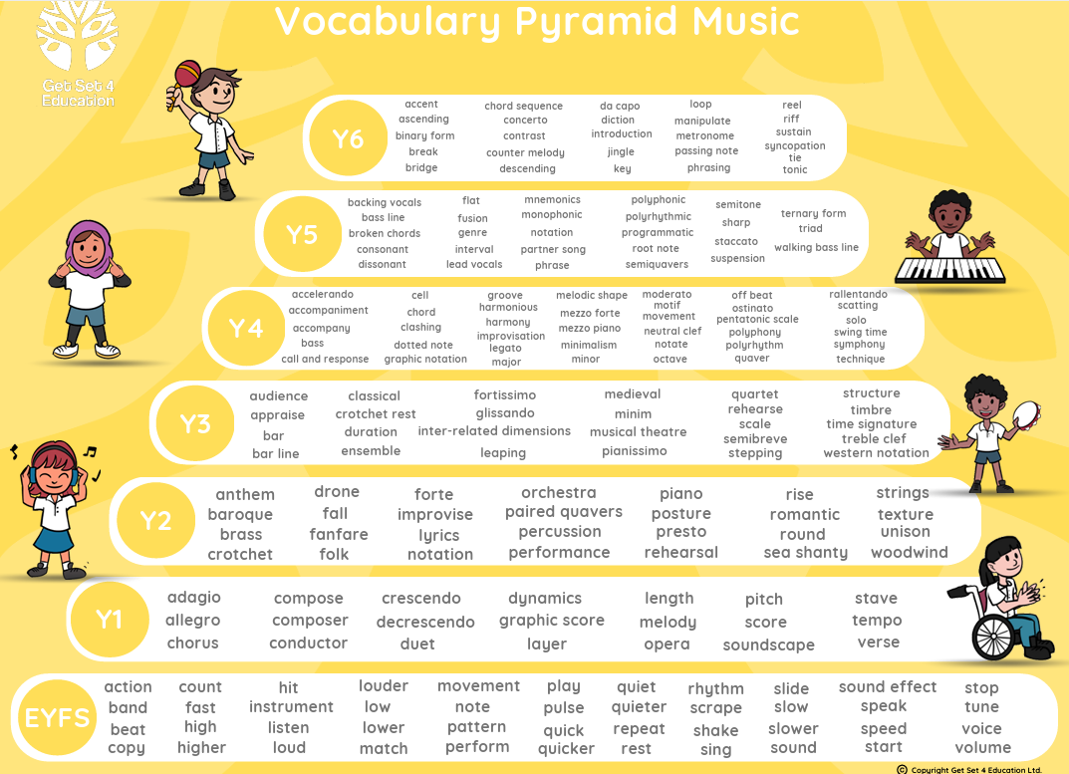

Christian Values in Music

Love | Compassion | Respect | Faith | Belonging
 |  |  |  | 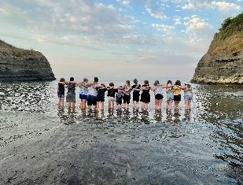
Creating – using music to create art, bringing joy to ourselves and others. | Inspiration - looking to others to help us improve and help others. | Respect – respecting and celebrating both our work and that of our peers. | Persevering – keep trying and practising to make progress in music. | Team work – working together to develop musical skills and to perform.
Imagination – creating something new and interesting. | Generalisation - spotting patterns and adapting them to develop music skills. | Open mindedness – being open to appreciating different forms of music, including those we are less familiar with and those from other cultures. | Making mistakes – understanding that to make a mistake is part of a learning journey. | Community links – sharing music with those around us.
Cross curricular links – using music to support learning in other curriculum areas. | Compassion – Understanding that we all have our own experiences, talents and opinions when it comes to music. | Tolerance – understanding and respect for others. | Self -confidence – celebrating our progress and achievements in music. | Expanding horizons – developing appreciation and understanding of music in other cultures and history.

SMSC in Music
Spiritual Development  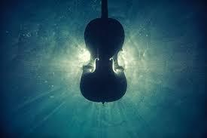 | Children:  - Demonstrate they are reflecting on their experiences and learning from reflection. They express their opinions about their own and their peer’s work.  - Show they understand human feelings and emotions and how these affect others e.g. enjoyment, disappointment, feelings of ‘awe’ and ‘wonder’ in their own and other’s music.  - Develop musical appreciation – through genre and culture.  - Respect others e.g. feedback from peers, or teachers is listened to and considered sensibly. Children are able to accept that in art often by making mistakes that learning begins.  - Accommodate differences and enable others to succeed – children are supportive of each other when working either individually or collaboratively on a project, such as playing in an ensemble.  - Ask questions, offer ideas and make connections for example when listening to music.  - Display creativity and imagination in developing music e.g. when composing or performing.  - Review what they and others have done and say what they might change in their current work or develop in their future work.
Moral  Development | Children  - They incorporate mutual respect and the consideration for others’ work and performance.  - Pupils are encouraged to show compassion when assessing the work of others. Understanding how their comments can build up or destroy another’s self-belief.  .
Social Development  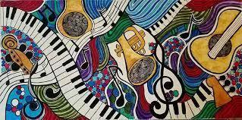 | Children:  - Work cooperatively with partners and in a structured and unstructured groups.  - Participate in musical experiences such as the Junior Summer Performance and church services.  - Demonstrate personal qualities such as thoughtfulness, honesty, respect for difference, moral principles, independence, inter-dependence  - Demonstrate leadership skills, for example when conducting a group.
Cultural  Development  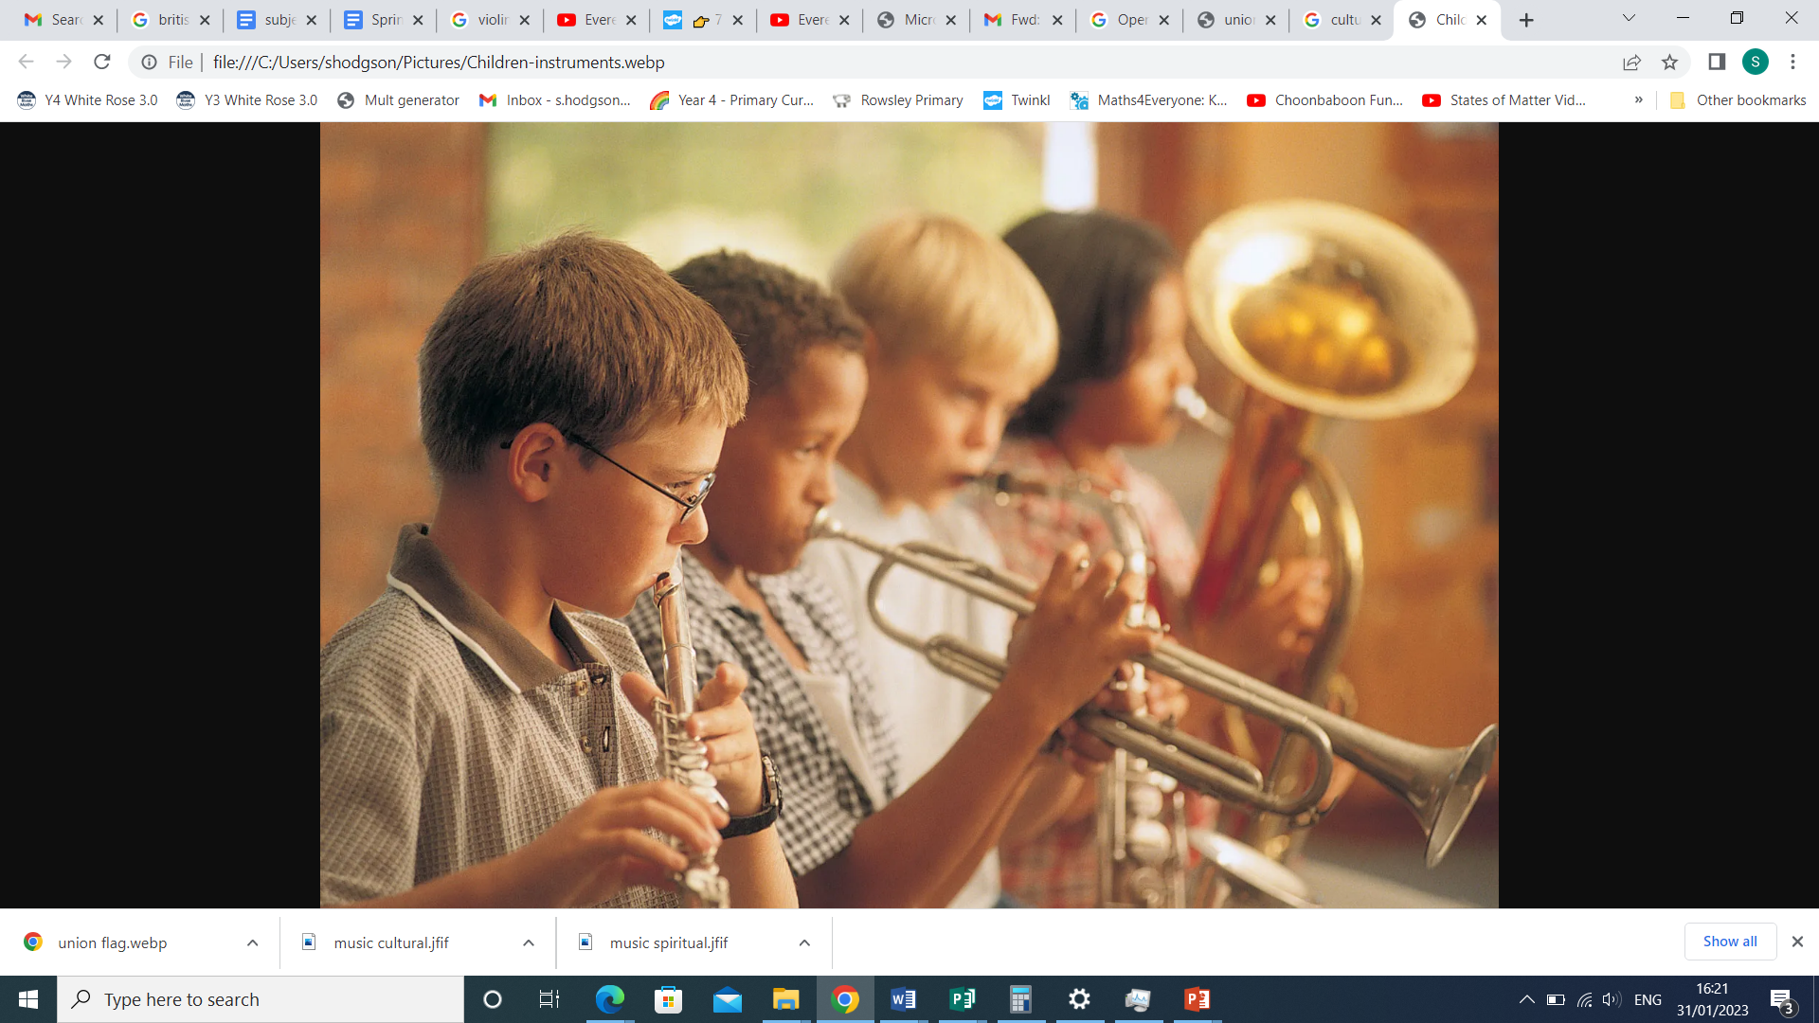 | Children:  - Engage with music from a range of cultures and genres, developing appreciation for music different to that they are familiar with.  - Understand the role of the musician in a range of cultures, times and contexts.
British Values   | At the Peak Tor Federation we recognise that our Music curriculum plays an important role in promoting British Values. We have planned our curriculum to ensure that through music our pupils can learn about the powerful messages art can convey and the impact it can have on others.  - Tolerance is promoted through listening to each other’s ideas, creative responses and understanding of different cultures and styles within art. Children are encouraged to question and explore whilst maintaining tolerance and respect for the views of others.  - We teach democracy by being aware and considering the views and values of others, particularly when working collaboratively. We may take votes and hold discussions when making decisions about our work, and collaborative projects.  - Rule of law- We understand the school rules and guidelines and recognise their importance in keeping ourselves and our peers safe. We use our instruments in accordance to the rules set by the music teacher. We know and understand the consequences of not following the rules.  - Mutual respect & tolerance – Pupils are taught to show respect for other opinions and performances.  - Individual Liberty - Pupils are given a chance to show their individuality through different musical opportunities, including singing performances and composing on instruments.  - British music is promoted throughout the school– for example through Musician of the Month or the traditional songs and hymns learned in collective worship.  - Children have the opportunity to work independently and as a team to build resilience and self-esteem through tasks, sharing ideas and resources.  - Peer-assessment is embedded in the Music curriculum which encourages pupils to support each other.

